

**ATSS’s**

**Institute of Industrial & Computer Management & Research, Nigdi**

**Academic Year 2023-2024**

**MCA II**

# **MASTER OF COMPUTER APPLICATION SAVITRIBAI PHULE PUNE UNIVERSITY**

**PROJECT REPORT ON**

**“Film Finder”**

|  |  |  |  |
| --- | --- | --- | --- |
| **Sr.No** | **Topic** | **Page** | **Remark** |
| **1** | **CHAPTER 1: INTRODUCTION** |  |  |
|  | 1.1 Existing System |  |  |
|  | 1.2 Need for System |  |  |
|  | 1.3 Scope of Work |  |  |
|  | 1.4 Operating Environment – Hardware and Software |  |  |
|  | 1.5 Detail Description of Technology Used |  |  |
| **2** | **CHAPTER 2: PROPOSED SYSTEM** |  |  |
|  | 2.1 Proposed system |  |  |
|  | 2.2 Objective of System |  |  |
|  | 2.3 User Requirement |  |  |
| **3** | **CHAPTER 3: ANALYSIS AND DESIGN** |  |  |
|  | 3.1 Architecture Diagram |  |  |
|  | 3.2 Sequence Diagram |  |  |
|  | 3.3 Use Case Diagram |  |  |
|  | 3.4 Component Diagram |  |  |
|  | 3.5 User Interface Design |  |  |
|  | 3.6 Module specification |  |  |
| **4** | **CHAPTER 4: USER MANUAL** |  |  |
|  | 4.1 Drawback and Limitations |  |  |
|  | 4.2 Proposed Enhancements |  |  |
|  | 4.3 Bibliography |  |  |
|  | **ANNEXURES** |  |  |
|  | ANNEXURE 1: USER INTERFACE SCREENS |  |  |
|  | ANNEXURE 2: OUTPUT REPORTS WITH DATA ( if any ) |  |  |
|  | ANNEXURE 3: SAMPLE PROGRAM CODE |  |  |

**CHAPTER 1 : INTRODUCTION**

* 1. Existing System:
* Users have to physically choose movies from libraries.
* Options included reading user reviews or randomly selecting a movie.
* System suggests to us what to watch without having to put effort into deciding what to watch.
  1. **Need for System:**
* **Diverse Preferences:** People have diverse tastes and preferences when it comes to movies. A recommender system helps in tailoring content recommendations to individual users, considering their viewing history, ratings, and preferences**.**
* **Vast Content Libraries:** Streaming platforms often have vast libraries of movies and TV shows. Recommender systems help users discover hidden gems and navigate through the extensive content catalog, making it easier to find content they might enjoy.
* **Enhanced User Satisfaction:** When users find content that aligns with their preferences, they are more likely to be satisfied with the platform's service. This satisfaction contributes to customer retention.
* **Differentiation:** A well-designed recommender system can set a platform apart from its competitors by offering a superior and more personalized user experience.
  1. Scope of Work
* Accurate movie recommendations to users.
* To improve the quality of movie recommendation system, such as accuracy, quality and scalability of system than the pure approaches. This is done using Hybrid approach by combining content based filtering and collaborative filtering,
* Eradicate the overload of the data, recommendation system is used as information filtering tool in social networking sites. Hence, there is a huge scope of exploration in this field for improving scalability, accuracy and quality of movie recommendation systems.
  1. Operating Environment –

Hardware:

Processor: Intel core Processor Pentium 4  
Operating System: Windows 7 and Above  
RAM: 2GB and Above  
Hard Disk: 40GB and Above

Software:

**Frontend:** Html, CSS, Javascript

**Frame Work:** Flask

**Language:** Python 3.11

**API:** TMDB

* 1. Detail Description of Technology Used
* HTML

HTML stands for Hyper Text Mark-up Language.

HTML is the standard markup language for creating Web pages.

HTML describes the structure of a Web  
page.

HTML consists of a series of elements.

HTML elements tell the browser how to display the content.

HTML elements label pieces of content such as "this is a heading", "this is a paragraph", "this is a link", etc.

• **CSS**CSS stands for Cascading Style Sheets. CSS describes how HTML  
elements are to be displayed on screen, paper, or in other media. CSS saves  
a lot of work. It can control the layout of multiple web pages all atonce.  
External style sheets are stored in CSS files.

• **JavaScript**It's the most popular programming language. It's in your browser.JavaScript  
also exists outside of the internet. JavaScript is Ideal for Newbies. JavaScript  
is Easy to Learn. You Can Create Visual Effects and Other Eye-catching.  
Aesthetic Features. JavaScript is Versatile.

* **Python**

Python is a high-level, general-purpose programming language. Its design philosophy emphasizes code readability with the use of significant indentation. Python is dynamically typed and garbage-collected. It supports multiple programming paradigms, including structured (particularly procedural), object-oriented and functional programming. It is often described as a "batteries included" language due to its comprehensive standard library.

* **Flask**:

Flask is a micro web framework written in Python. It is classified as a microframework because it does not require particular tools or libraries. It has no database abstraction layer, form validation, or any other components where pre-existing third-party libraries provide common functions. However, Flask supports extensions that can add application features as if they were implemented in Flask itself. Extensions exist for object-relational mappers, form validation, upload handling, various open authentication technologies and several common framework related tools.

* API:

API stands for Application Programming Interface. In the context of APIs, the word Application refers to any software with a distinct function. Interface can be thought of as a contract of service between two applications. This contract defines how the two communicate with each other using requests and responses.

**CHAPTER 2 : PROPOSED SYSTEM**

2.1 Proposed System:

* Content-Based Filtering:

It considers the characteristics of movies, such as genre, director, and actors, to recommend items that are similar to those a user has liked in the past.

* Integration with External Data Sources:

It integrate external data sources, such as movie databases or APIs(TMDB), to enrich its catalog of movies and ensure up-to-date information.

* Sentiments:

Allowing users to view explicit feedback/reaction on recommended movies.

2.2 Objectives of System:

To Collect a diverse and comprehensive dataset of movie information, including details such as genre, cast, crew, plot summaries, and user reviews.

To Extract relevant features from the movie dataset, such as genre, keywords, and metadata, to build a comprehensive representation of each movie.

To Implement sentiment analysis on user reviews to understand the emotional tone and opinions expressed by users towards different movies.

To Develop algorithms that analyze the content features of movies to recommend similar ones.

To Develop an intuitive and user-friendly interface that presents movie recommendations and allows users to explore and refine their preferences.

2.3 User Requirements:

Content-Based Recommendation:

* Movie Metadata: Utilize movie features such as genre, director, actors, release year, and plot summary.

Sentiment Analysis:

* User Sentiment Analysis: Analyze user reviews, comments, or ratings to understand the sentiment associated with their preferences.

Ease of Use:

* User-Friendly Interface: Design an intuitive and user-friendly interface to make it easy for users to input preferences and explore recommended movies.

Diversity in Recommendations:

* Avoid Redundancy: Ensure that the system does not repeatedly recommend the same or similar movies.

Cross-Platform Compatibility:

* Ensure that the recommender system is accessible and functional across various platforms, such as web browsers, mobile apps, and smart TVs.

**CHAPTER 3 : ANALYSIS & DESIGN**

3.1 Architecture Diagram:

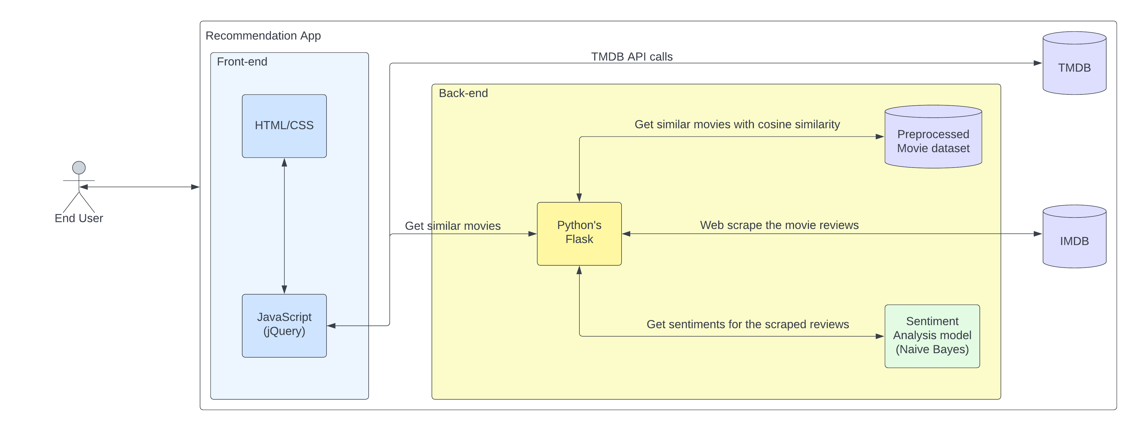

3.2 Sequence Diagram: 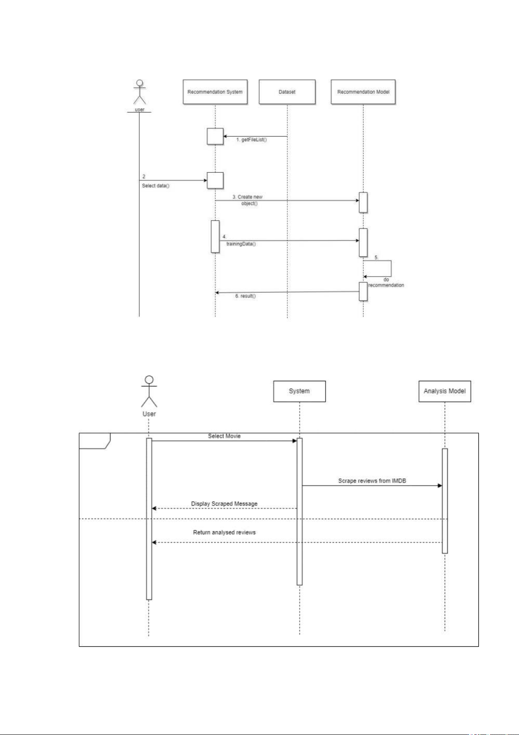

3.3 Use Case Diagrams:

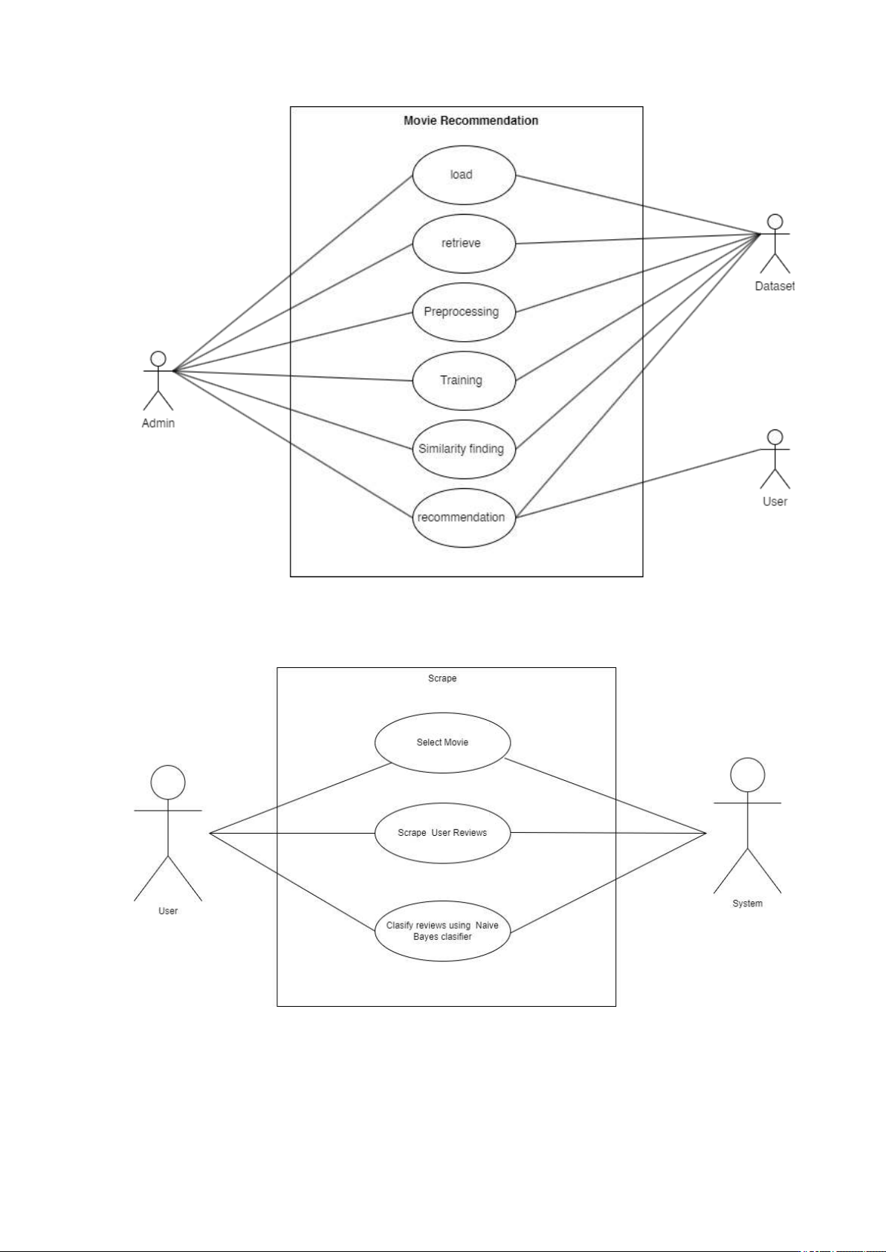

3.4 Component diagram:

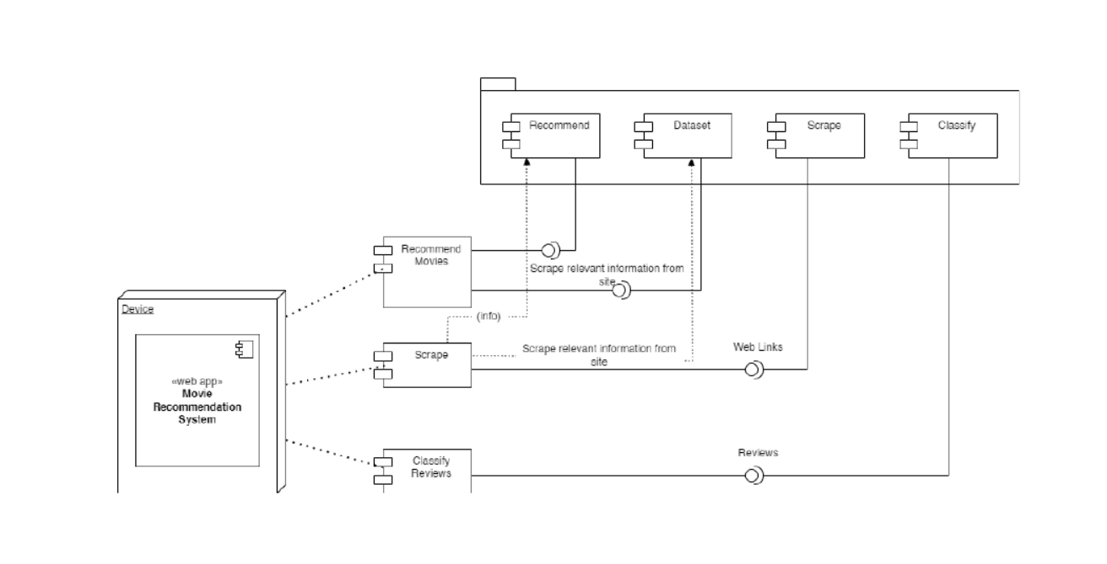

3.5 DFD diagram:

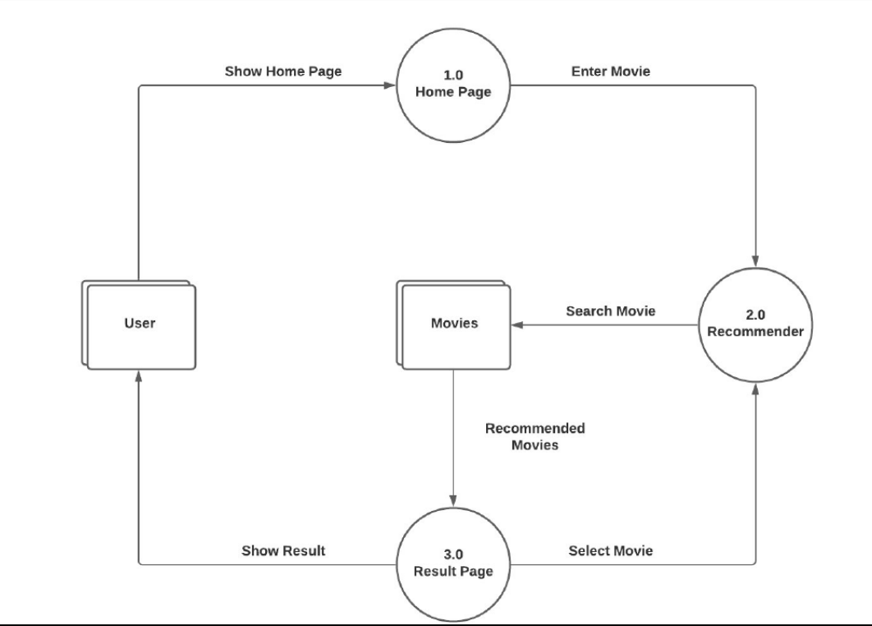

3.5 User Interface Design (Screens etc.)

Home Page:

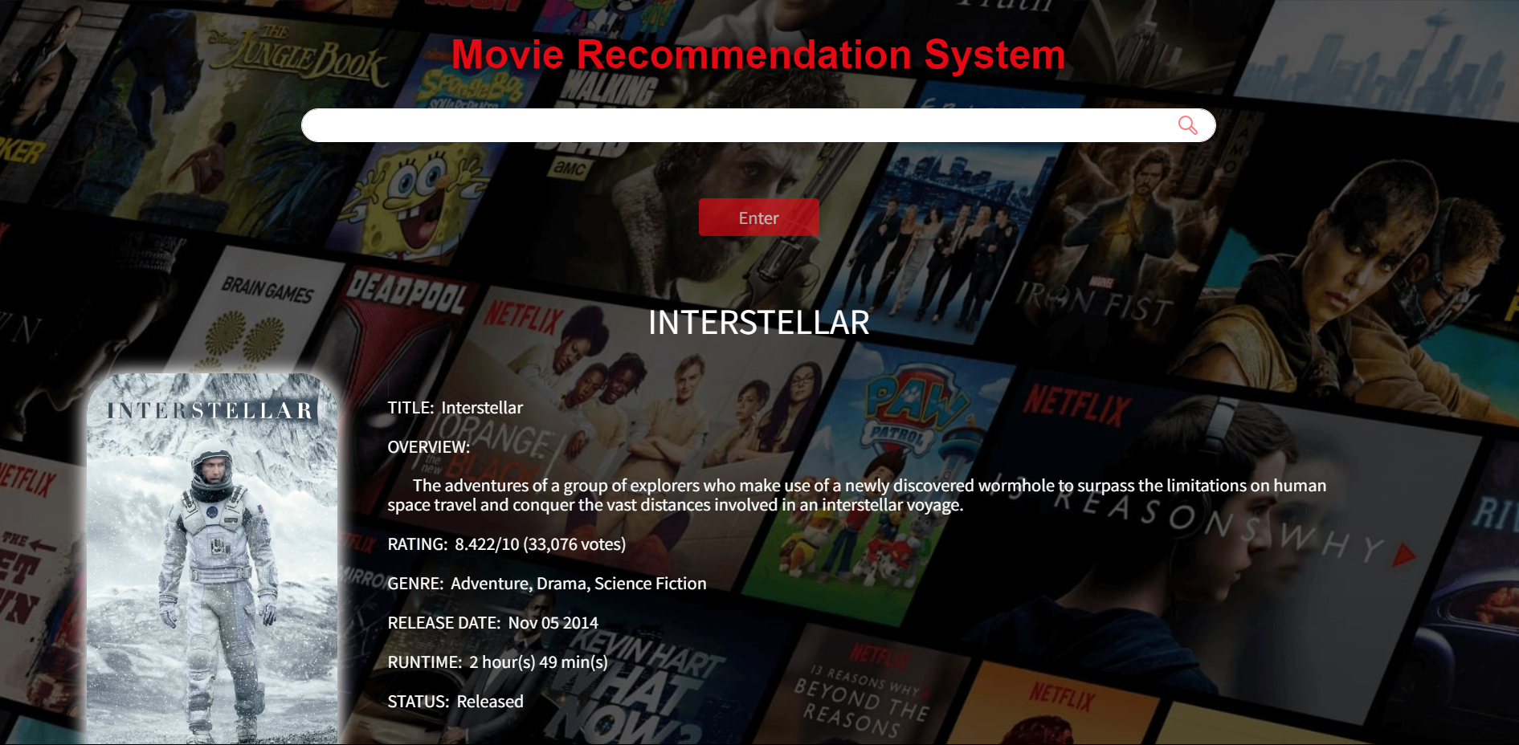

Review System:

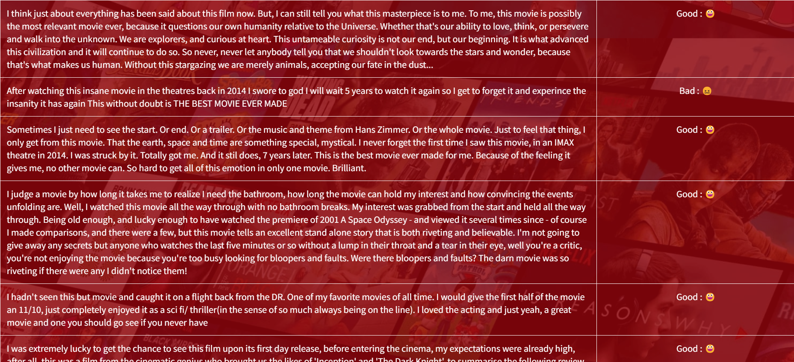

Cast System:

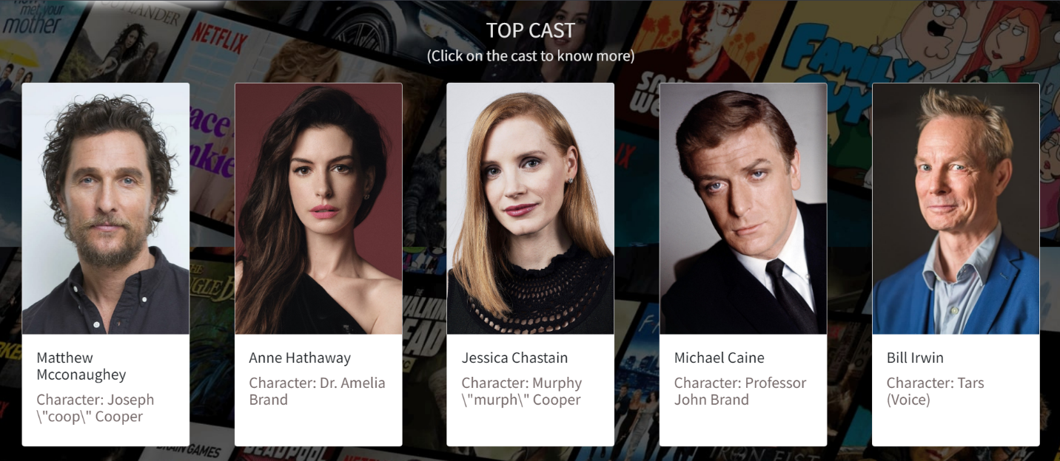

Recommend System:

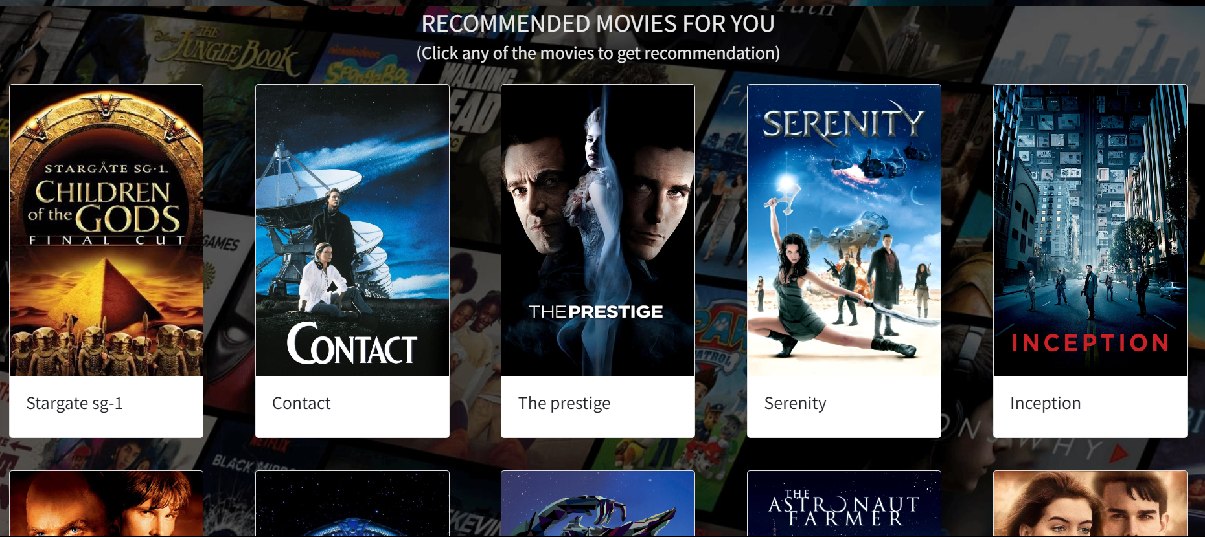

3.6 Module Specification:

Data Collection and Preprocessing:

* Module: Data Collection
  + Functionality: Collect movie data from various sources, such as user ratings, movie descriptions, and reviews.
* Module: Data Preprocessing
  + Functionality: Clean and preprocess the collected data, handling missing values, removing duplicates, and formatting the data for further analysis.

Content-based Filtering:

* Module: Feature Extraction
  + Functionality: Extract relevant features from movie data, such as genre, director, cast, and keywords.
  + Module: Vectorization
* Functionality: Transform textual data (e.g., movie descriptions) into numerical vectors using vectorization.

Module: Similarity Calculation

* + Functionality: Calculate the similarity between movies based on their extracted features.
* Module: Recommendation Engine
  + Functionality: Generate movie recommendations based on movie similarities.

Sentiment Analysis:

* Module: Text Sentiment Analysis
  + Functionality: Perform sentiment analysis on user reviews or comments associated with movies.
* Module: Sentiment Integration
  + Functionality: Integrate sentiment scores into the recommendation system to enhance personalization.

User Interface:

* Module: UI Design
  + Functionality: Design and implement a user interface for users to interact with the recommendation system.

Deployment:

* Module: Deployment
  + Functionality: Deploy the recommender system in a production environment, making it accessible to users.

**CHAPTER 4: USER MANUAL**

Drawbacks and Limitations:

Proposed Enhancements:

Hybrid Recommender Systems:Integrate collaborative filtering techniques with content-based methods to benefit from the strengths of both approaches. Hybrid systems often provide more accurate and diverse recommendations.

User Profiles: Create more detailed user profiles, including preferences for specific actors, directors, or even visual styles.

Explainability: Enhance the system's ability to provide explanations for recommendations, helping users understand why certain movies are being suggested.

Mobile Optimization: Optimize the recommender system for mobile platforms, considering limited screen space and different user behaviors.

Content-based Methods for New Items: Address the "cold start" problem by employing content-based methods to recommend new or less-reviewed movies before collaborative filtering becomes effective.

Bibliography :

Websites**:**• https://www.tutorialspoint.com/jsp/index.html  
• https://www.stackoverflow.com/  
• https://www.geekforgeeks.com/

**ANNEXURES**:

ANNEXURE 1 : USER INTERFACE SCREENS

Homepage:



Review page:



Cast Page:



Other Screens:

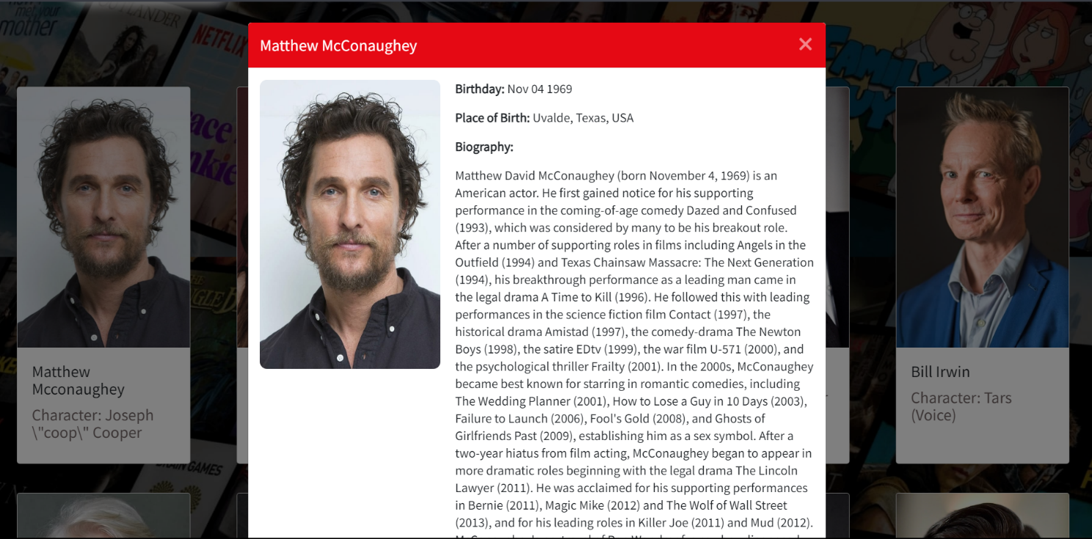

ANNEXURE 2 : OUTPUT REPORTS WITH DATA ( if any )

Reviews using Sentiement anyalsis:



ANNEXURE 3 : SAMPLE PROGRAM CODE

1.Main.py:

import numpy as np

import pandas as pd

from flask import Flask, render_template, request

from sklearn.feature_extraction.text import CountVectorizer

from sklearn.metrics.pairwise import cosine_similarity

import json

import bs4 as bs

import urllib.request

import pickle

import requests

# load the nlp model and tfidf vectorizer from disk

filename = 'nlp_model.pkl'

clf = pickle.load(open(filename, 'rb'))

vectorizer = pickle.load(open('tranform.pkl','rb'))

def create_similarity():

data = pd.read_csv('main_data.csv')

# creating a count matrix

cv = CountVectorizer()

count_matrix = cv.fit_transform(data['comb'])

# creating a similarity score matrix

similarity = cosine_similarity(count_matrix)

return data,similarity

def rcmd(m):

m = m.lower()

try:

data.head()

similarity.shape

except:

data, similarity = create_similarity()

if m not in data['movie_title'].unique():

return('Sorry! The movie you requested is not in our database. Please check the spelling or try with some other movies')

else:

i = data.loc[data['movie_title']==m].index[0]

lst = list(enumerate(similarity[i]))

lst = sorted(lst, key = lambda x:x[1] ,reverse=True)

lst = lst[1:11] # excluding first item since it is the requested movie itself

l = []

for i in range(len(lst)):

a = lst[i][0]

l.append(data['movie_title'][a])

return l

# converting list of string to list (eg. "["abc","def"]" to ["abc","def"])

def convert_to_list(my_list):

my_list = my_list.split('","')

my_list[0] = my_list[0].replace('["','')

my_list[-1] = my_list[-1].replace('"]','')

return my_list

def get_suggestions():

data = pd.read_csv('main_data.csv')

return list(data['movie_title'].str.capitalize())

app = Flask(__name__)

@app.route("/")

@app.route("/home")

def home():

suggestions = get_suggestions()

return render_template('home.html',suggestions=suggestions)

@app.route("/similarity",methods=["POST"])

def similarity():

movie = request.form['name']

rc = rcmd(movie)

if type(rc)==type('string'):

return rc

else:

m_str="---".join(rc)

return m_str

@app.route("/recommend",methods=["POST"])

def recommend():

# getting data from AJAX request

title = request.form['title']

cast_ids = request.form['cast_ids']

cast_names = request.form['cast_names']

cast_chars = request.form['cast_chars']

cast_bdays = request.form['cast_bdays']

cast_bios = request.form['cast_bios']

cast_places = request.form['cast_places']

cast_profiles = request.form['cast_profiles']

imdb_id = request.form['imdb_id']

poster = request.form['poster']

genres = request.form['genres']

overview = request.form['overview']

vote_average = request.form['rating']

vote_count = request.form['vote_count']

release_date = request.form['release_date']

runtime = request.form['runtime']

status = request.form['status']

rec_movies = request.form['rec_movies']

rec_posters = request.form['rec_posters']

# get movie suggestions for auto complete

suggestions = get_suggestions()

# call the convert_to_list function for every string that needs to be converted to list

rec_movies = convert_to_list(rec_movies)

rec_posters = convert_to_list(rec_posters)

cast_names = convert_to_list(cast_names)

cast_chars = convert_to_list(cast_chars)

cast_profiles = convert_to_list(cast_profiles)

cast_bdays = convert_to_list(cast_bdays)

cast_bios = convert_to_list(cast_bios)

cast_places = convert_to_list(cast_places)

# convert string to list (eg. "[1,2,3]" to [1,2,3])

cast_ids = cast_ids.split(',')

cast_ids[0] = cast_ids[0].replace("[","")

cast_ids[-1] = cast_ids[-1].replace("]","")

# rendering the string to python string

for i in range(len(cast_bios)):

cast_bios[i] = cast_bios[i].replace(r'\n', '\n').replace(r'\"','\"')

# combining multiple lists as a dictionary which can be passed to the html file so that it can be processed easily and the order of information will be preserved

movie_cards = {rec_posters[i]: rec_movies[i] for i in range(len(rec_posters))}

casts = {cast_names[i]:[cast_ids[i], cast_chars[i], cast_profiles[i]] for i in range(len(cast_profiles))}

cast_details = {cast_names[i]:[cast_ids[i], cast_profiles[i], cast_bdays[i], cast_places[i], cast_bios[i]] for i in range(len(cast_places))}

# web scraping to get user reviews from IMDB site

sauce = urllib.request.urlopen('https://www.imdb.com/title/{}/reviews?ref_=tt_ov_rt'.format(imdb_id)).read()

soup = bs.BeautifulSoup(sauce,'lxml')

soup_result = soup.find_all("div",{"class":"text show-more__control"})

reviews_list = [] # list of reviews

reviews_status = [] # list of comments (good or bad)

for reviews in soup_result:

if reviews.string:

reviews_list.append(reviews.string)

# passing the review to our model

movie_review_list = np.array([reviews.string])

movie_vector = vectorizer.transform(movie_review_list)

pred = clf.predict(movie_vector)

reviews_status.append('Good' if pred else 'Bad')

# combining reviews and comments into a dictionary

movie_reviews = {reviews_list[i]: reviews_status[i] for i in range(len(reviews_list))}

# passing all the data to the html file

return render_template('recommend.html',title=title,poster=poster,overview=overview,vote_average=vote_average,

vote_count=vote_count,release_date=release_date,runtime=runtime,status=status,genres=genres,

movie_cards=movie_cards,reviews=movie_reviews,casts=casts,cast_details=cast_details)

if __name__ == '__main__':

app.run(debug=True)

**Autocomplete.js:**

new autoComplete({

data: { // Data src [Array, Function, Async] | (REQUIRED)

src: films,

},

selector: "#autoComplete", // Input field selector | (Optional)

threshold: 2, // Min. Chars length to start Engine | (Optional)

debounce: 100, // Post duration for engine to start | (Optional)

searchEngine: "strict", // Search Engine type/mode | (Optional)

resultsList: { // Rendered results list object | (Optional)

render: true,

container: source => {

source.setAttribute("id", "food_list");

},

destination: document.querySelector("#autoComplete"),

position: "afterend",

element: "ul"

},

maxResults: 5, // Max. number of rendered results | (Optional)

highlight: true, // Highlight matching results | (Optional)

resultItem: { // Rendered result item | (Optional)

content: (data, source) => {

source.innerHTML = data.match;

},

element: "li"

},

noResults: () => { // Action script on noResults | (Optional)

const result = document.createElement("li");

result.setAttribute("class", "no_result");

result.setAttribute("tabindex", "1");

result.innerHTML = "No Results";

document.querySelector("#autoComplete_list").appendChild(result);

},

onSelection: feedback => { // Action script onSelection event | (Optional)

document.getElementById('autoComplete').value = feedback.selection.value;

}

**});**